

***Operating Lease Support System Phase-2 Project***

***for***

****

***Functional Specification***

***FC.AB.2.2 Approval SKD***

Revision 1.0

**PT. Berlian Sistem Informasi**

KTB Annex Bld. 4th Floor, Jl. Jend. A. Yani. Pulomas,

Tel. +62 21 4786 7575 (Hunting) Fax. +62 21 4714964 www.bsi.co.id

Document Control

|  |  |
| --- | --- |
| **Author** | Raymond |
| **File Name** |  |
| **Path** |  |
| **Number of Page** |  |

Revision History

|  |  |  |  |
| --- | --- | --- | --- |
| **Date** | **Revision** | **Description** | **Author** |
| 1/10/2015 | 0.0 | Initialization | Raymond |
| 24/11/2015 | 0.1 | * Adding Functional Specification for Check SKD * Adding Functional Specification for Approve SKD * Adding Functional Specification for Revise SKD * Adding Functional Specification for Reject SKD | Raymond |
| 23/12/2015 | 1.0 | 1st baseline | Raymond |

Distribution List

|  |  |  |
| --- | --- | --- |
| Name | Organization | Roles |
| Mr. Jin Nishimura | Dipo Star Finance, PT | DSF Project Director |
| Mr. Shinji Hosokawa | Dipo Star Finance, PT | DSF Project Advisor |
| Mr. Ahmad Fikri | Dipo Star Finance, PT | DSF Project Advisor |
| Mr. Abdul Somad | Dipo Star Finance, PT | DSF Project Manager |
| Mr. Delta Riangga | Dipo Star Finance, PT | DSF Key User |
| Mr. Mochamad Idris | Dipo Star Finance, PT | DSF Key User |
| Mrs. Herni Hembang | Dipo Star Finance, PT | DSF Key User |
| Mr. Junaidi Didy | Dipo Star Finance, PT | DSF Key User |
| Mr.Dedy Supriyadi | Dipo Star Finance, PT | DSF Key User |
| Mrs. Elke Hilviana | Dipo Star Finance, PT | DSF Key User |
| Mr. Mukhlis Ibrahim | Dipo Star Finance, PT | DSF IT Department Representative |
| Mr. Roby Wijaya | Dipo Star Finance, PT | DSF IT Department Representative |
| Mr. Daiki Kamada | Berlian Sistem Informasi, PT | BSI Project Director |
| Mr. Feri Irawan | Berlian Sistem Informasi, PT | BSI Project Advisor |
| Mr. Grand Zah Putra | Berlian Sistem Informasi, PT | BSI Project Manager |
| Mr. Raymond | Berlian Sistem Informasi, PT | BSI Business Analyst |

Document Approval

By signing this document I acknowledge I have read the document and give the Project Management Team approval to proceed.

|  |  |  |  |
| --- | --- | --- | --- |
| Role | Name | Signature | Date |
| DSF Project Director | Mr. Jin Nishimura |  |  |
| DSF Project Advisor | Mr. Ahmad Fikri |  |  |
| DSF Project Manager | Mr. Abdul Somad |  |  |
| DSF IT Department Representative | Mr. Mukhlis Ibrahim |  |  |
| BSI Project Director | Mr. Daiki Kamada |  |  |
| BSI Project Advisor | Mr. Feri Irawan |  |  |
| BSI Project Manager | Mr. Grand Zah Putra |  |  |
| BSI Business Analyst | Mr. Raymond |  |  |

Table of Contents

Document Control 2

Revision History 2

Distribution List 3

Document Approval 4

1. Introduction 6

1.1 Purpose 6

1.2 Scope 6

1.3 Definition, Acronyms, and Abbreviations 6

1.4 References 6

2. Configuration 7

3. Specification Detail: FC.AB.2.2 Approval SKD 7

3.1 Purpose 7

3.2 Screen of Configuration Access 7

3.3 Screen Functionality 7

3.4 Operation Flow 8

3.5 Screen Design 9

3.6 Component Screen Functionality 12

3.7 Operation Description 15

3.8 Data Structure 22

3.9 Screen Item List 31

3.10 Entity Relationship Diagram 31

1. Introduction
   1. Purpose

Functional Specification is a document to describe the detail of functions system which includes screen design, report, and logic formula. This document will be used for system development.

* 1. Scope

Functional Specification Document contains screen design, screen functionality, process flow, and data structure of FC.AB.2.1 Manage SKD for Phase-2

Here are the scope for FC.AB.2.1 Manage SKD

1. **AB.2.1.3 Approve SKD**

To approve a SKD (the function is the same with Check)

1. **AB.2.1.4 Reject SKD**

To reject a SKD and change it into Reject status

1. **AB.2.1.5 Revise SKD**

To set a SKD into revise status

Output from this functions is:

N/A

* 1. Definition, Acronyms, and Abbreviations

1. OPL = Operating Lease
2. DSF = Dipo Star Finance
3. BSI = Berlian Sistem Informasi
4. HOB = Head of Branch
5. HOD = Head of Department
6. RM = Regional Manager
7. SKD = Surat Keputusan Direksi/ Board of Director’s Decree
   1. References

This functional specification document refers to **“To Be Design” AB. Marketing Process**, module:

1. AB.2 SKD Process

* AB.2.2 SKD Approval of Operating Lease

1. Configuration

* N/A

1. Specification Detail: FC.AB.2.2 Approval SKD
   1. Purpose

The screens used in Approval SKD are used to Check, Approve, Revise, and Reject the SKD and generate an output as a print form of the SKD Form.

* 1. Screen of Configuration Access

Here are the access right for users:

|  |  |  |  |  |  |
| --- | --- | --- | --- | --- | --- |
| ***User*** | ***Check*** | ***Approve*** | ***Reject*** | **Revise** | **Authorization** |
| Marketing Officer | - | - | - | - | - |
| Head of Branch | v | v | v | v | v |
| Head of Department | v | v | v | v | v |
| Regional Manager | v | v | v | v | v |
| Advisor | v | v | v | v | v |
| Director | v | v | v | v | v |
| President Director | v | v | v | v | v |
| Shareholder’s Meeting | - | v | v | v | v |

* 1. Screen Functionality

1. Check SKD
2. Approve SKD
3. Revise SKD
4. Reject SKD
   1. Operation Flow

Below is operation flow for Monitoring and print unit preparation process refer to **To Be Design Document Marketing Process**, **AB.2 Board of Director’s Decree/ Surat Keputusan Direksi (SKD)**:

|  |  |
| --- | --- |
| **PIC PC** | **Process** |
|  | Status  (Tb\_OPL\_Status)  F:\FINAL\SKD\SKD_View.png  Branch  (Tb\_OPL\_Branch)  Supplier Master data  (Supplier)    Quotation  (OPLQuotation)  SKD Detail  (Tb\_MKT\_SKD\_Dtl)  SKD  (Tb\_MKT\_SKD)  Note:  Source  Output & Input |

* 1. Screen Design
* *View SKD (for approval)*

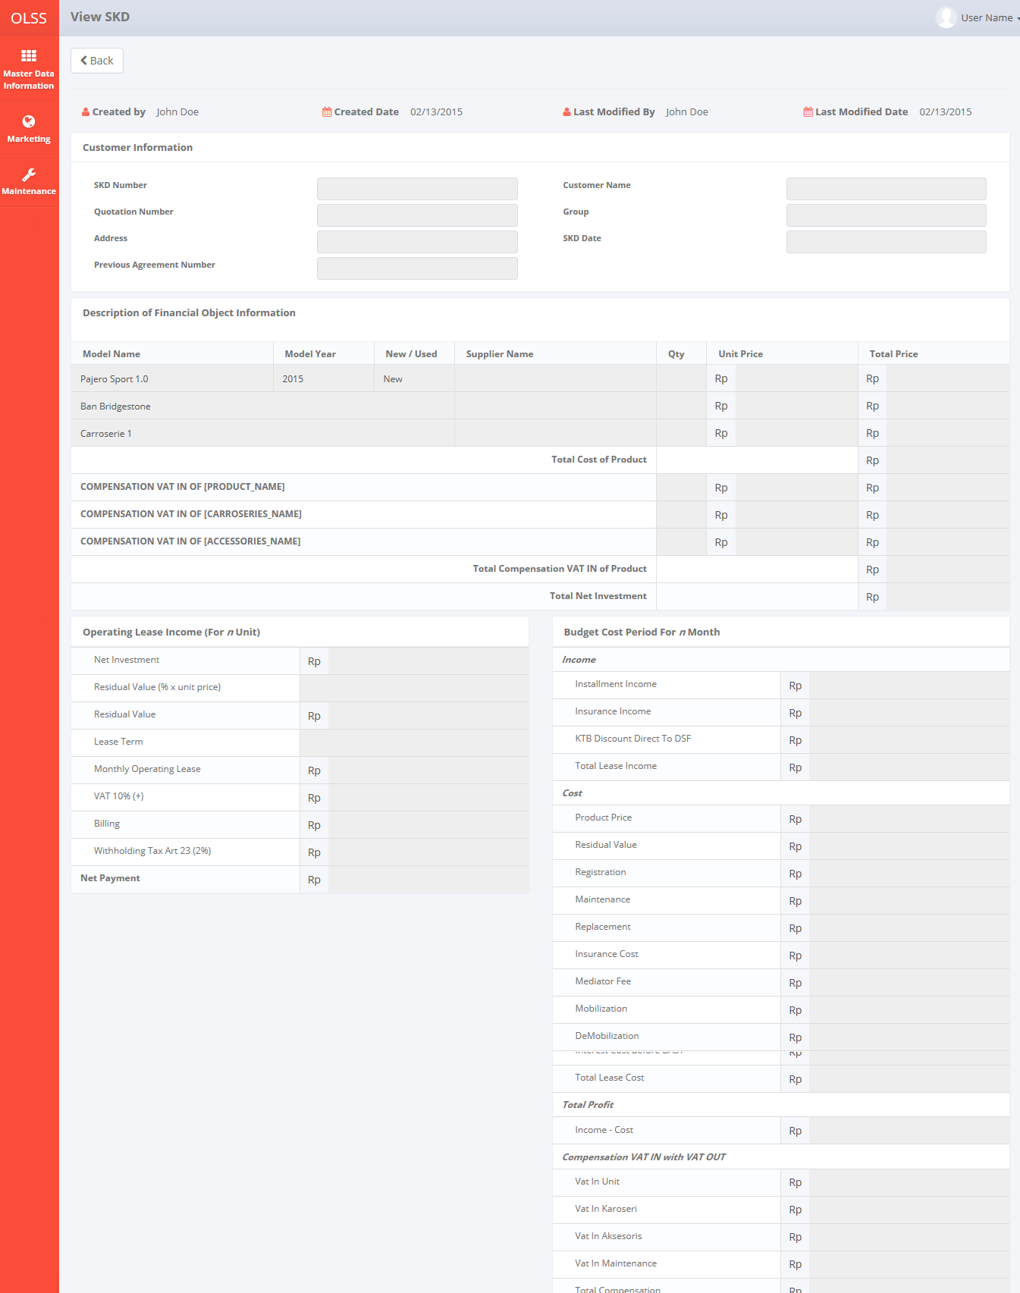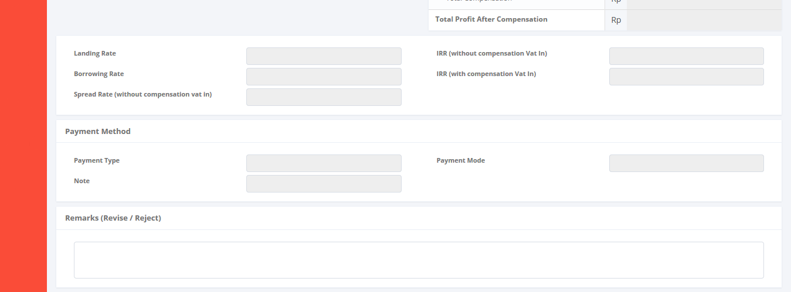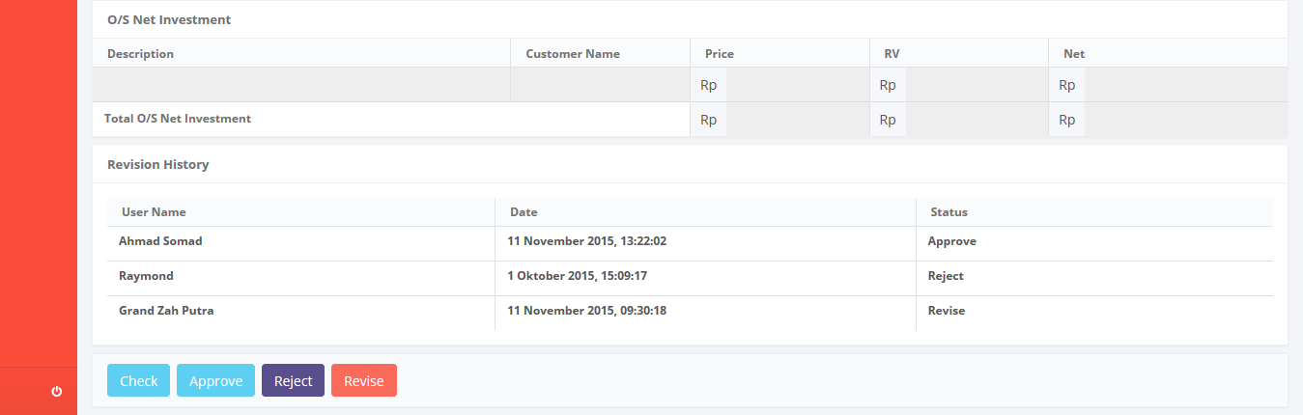

*Screen 1. View SKD (for approval)*

* *Notification After Check*



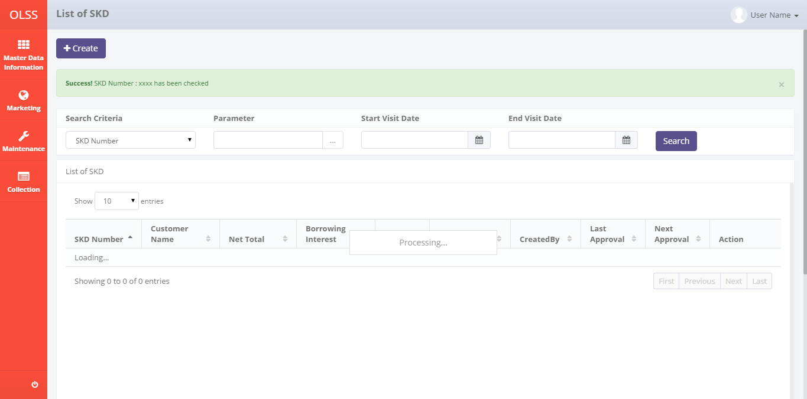

*Screen 2. List of SKD after check*

* *Notification after Approve*



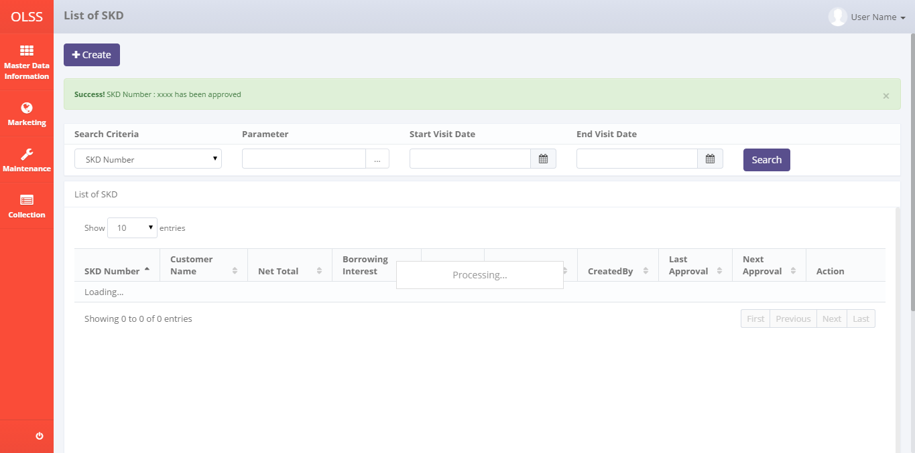

*Screen 3. List of SKD after approve*

* *Notification after Reject*



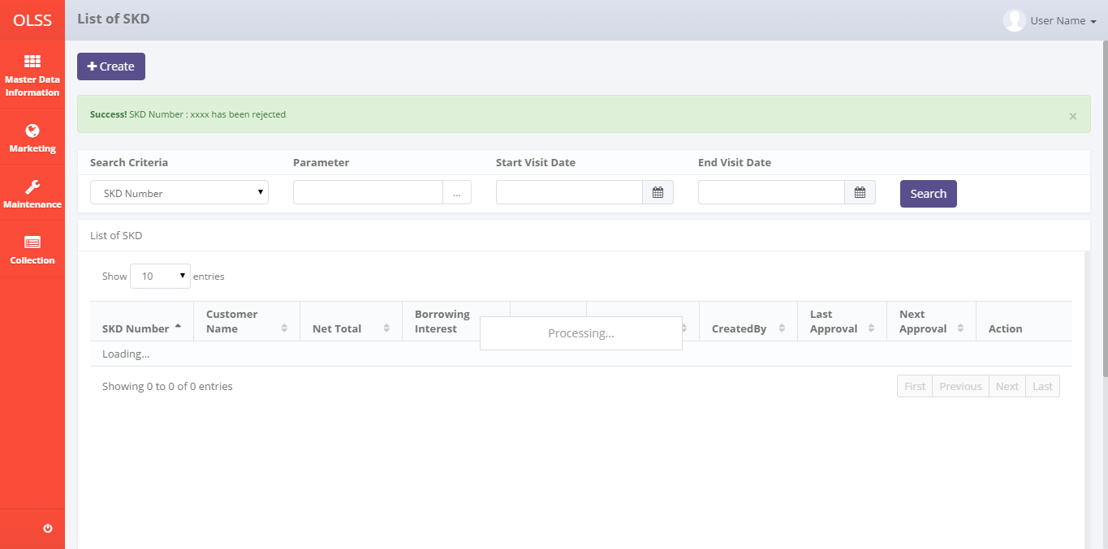

*Screen 4. List of SKD after reject*

* *Notification after Revise*



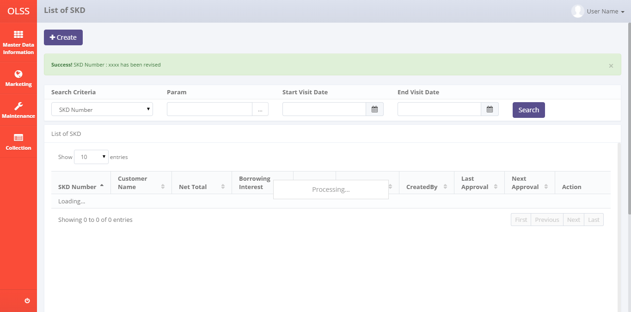

*Screen 5. List of SKD after revise*

* 1. Component Screen Functionality
  2. **View SKD (for approval)**

Here are the screen functions from each component in **Screen 1. View SKD (for approval)**:

|  |  |  |  |
| --- | --- | --- | --- |
| ***No*** | ***Component*** | ***Name*** | ***Function*** |
| **Customer Information** | | | |
| 1 | Label | View SKD | View SKD title |
| 2 | Button | Back | Back to Previous Screen |
| 3 | Label | Created By | Displaying Created By |
| 4 | Label | Created Date | Displaying Created Date |
| 5 | Label | Last Modified By | Displaying Last Modified By |
| 6 | Label | Last Modified Date | Displaying Last Modified Date |
| 7 | Text Field | SKD Number | Displaying SKD Number created |
| 8 | Searching Box | Quotation Number | To generate searching screen for Quotation No |
| 9 | Text Field | Address | To input Address value |
| 10 | Text Field | Customer Name | To input Customer Name value |
| 11 | Text Field | Group | To input Group value |
| 12 | Date Picker | SKD Date | To input SKD created date value |
| 13 | Text Field | Previous Agreement Number | Displaying Previous Agreement Number |
| **Description of Financial Object Information** | | | |
| 14 | Text Field | Model Name | Displaying Model Name |
| 15 | Text Field | Model Year | Displaying Model Year |
| 16 | Text Field | New / Used | Displaying New / Used |
| 17 | Searching Box | Supplier Name | To generate searching screen for Supplier Name |
| 18 | Text Field | Qty | Displaying Qty |
| 19 | Text Field | Unit Price | Displaying Unit Price |
| 20 | Text Field | Total Price | Displaying Total Price |
| 21 | Text Field | Total Cost of Product | Displaying Total Cost of Product |
| 22 | Text Field | Compensation VAT IN of “Unit” | Displaying Compensation VAT IN of “Unit” |
| 23 | Text Field | Compesation VAT IN of “Carrosserie” | Displaying Compensation VAT IN of “Carrosserie” |
| 24 | Text Field | Compensation VAT IN of “Accessories” | Displaying Compensation VAT IN of “Accessories” |
| 25 | Text Field | Total Compensation VAT IN of Product | Displaying Total Compensation VAT IN of Product |
| 26 | Text Field | Total Net Investment | Displaying Total Net Investment |
| **Operating Lease Income (For *n* Unit)** | | | |
| 27 | Text Field | Net Investment | Displaying Net Investment |
| 28 | Text Field | Residual Value (% x unit price) | Displaying Residual Value (% x unit price) |
| 29 | Text Field | Residual Value | Displaying Residual Value |
| 30 | Text Field | Lease Term | Displaying Lease Term |
| 31 | Text Field | Monthly Operating Lease | Displaying Monthly Operating Lease |
| 32 | Text Field | VAT 10% (+) | Displaying VAT 10% (+) |
| 33 | Text Field | Billing | Displaying Billing |
| 34 | Text Field | Witholding Tax Art 23 (2%) | Displaying Witholding Tax Art 23 (2%) |
| 35 | Text Field | Net Payment | Displaying Net Payment |
| **Budget Cost Period For *n* Month** | | | |
| 36 | Label | Income | Displaying Income label |
| 37 | Text Field | Installment Income | Displaying Installment Income |
| 38 | Label | Insurance Income | Displaying Budget Cost Period For n Month label |
| 39 | Text Field | KTB Discount Direct To DSF | Displaying KTB Discount Direct To DSF |
| 40 | Text Field | Total Lease Income | Displaying Total Lease Income |
| 41 | Label | Cost | Displaying Cost label |
| 42 | Text Field | Product Price | Displaying Product Price |
| 43 | Text Field | Residual | Displaying Residual |
| 44 | Text Field | Registration | Displaying Registration |
| 45 | Text Field | Maintenance | Displaying Maintenance |
| 46 | Text Field | Replacement | Displaying Replacement |
| 47 | Text Field | Insurance Cost | Displaying Insurance Cost |
| 48 | Text Field | Mediator Fee | Displaying Mediator Fee |
| 49 | Text Field | Mobilization | Displaying Mobilization |
| 50 | Text Field | DeMobilization | Displaying DeMobilization |
| 51 | Text Field | Interest Cost | Displaying Interest Cost |
| 52 | Text Field | Term of Payment Cost | Displaying Term of Payment Cost |
| 53 | Text Field | Interest Cost Before BAST | Displaying Interest Cost Before BAST |
| 54 | Text Field | Total Lease Cost | Displaying Total Lease Cost |
| 55 | Label | Total Profit | Displaying Total Profit label |
| 56 | Text Field | Income - Cost | Displaying Income - Cost |
| 57 | Label | Compensation VAT IN with VAT OUT | Displaying Compensation VAT IN with VAT OUT label |
| 58 | Text Field | Vat In Unit | Displaying Vat In Unit |
| 59 | Text Field | VAT In Carrosserie | Displaying VAT In Carrosserie |
| 60 | Text Field | VAT In Accessories | Displaying VAT In Accessories |
| 61 | Text Field | VAT In Maintenance | Displaying VAT In Maintenance |
| 62 | Text Field | Total Compensation | Displaying Total Compensation |
| 63 | Text Field | Total Profit After Compensation | Displaying Total Profit After Compensation |
| 64 | Text Field | Landing Rate | Displaying Landing Rate |
| 65 | Text Field | Borrowing Rate | Displaying Borrowing Rate |
| 66 | Text Field | Spread Rate (without compensation vat in) | Displaying Spread Rate (without compensation vat in) |
| 67 | Text Field | IRR (without compensation Vat In) | Displaying IRR (without compensation Vat In) |
| 68 | Text Field | IRR (with compensation Vat In) | Displaying IRR (with compensation Vat In) |
| **Payment Method** | | | |
| 69 | Text Field | Payment Type | Displaying Payment Type |
| 70 | Text Field | Payment Mode | Displaying Payment Mode |
| 71 | Text Field | Notes | Displaying Notes |
| **O/S Net Investment** | | | |
| 72 | Text Field | Description | To show the Description of SKD Net Investment data row |
| 73 | Text Field | Customer Name | To show Customer Name of the SKD Data in description |
| 74 | Text Field | Price | To show Price of the SKD Data in description |
| 75 | Text Field | RV | To show RV of the SKD Data in description |
| 76 | Text Field | Net | To show Net of the SKD Data in description |
| 77 | Text Field | Total O/S Net Investment for Price, RV, and Net | Total amount of Price, RV, and Net |
| **Footer** | | | |
| 78 | Text Area | Remarks (Reject/ Revise) | To input remarks of revision or rejection |
| 79 | Button | Check | To check a SKD |
| 80 | Button | Approve | To approve a SKD |
| 81 | Button | Reject | To reject a SKD |
| 82 | Button | Revise | To revise a SKD |
| **Revision History** | | | |
| 83 | Label | Revision History | Revision History sub-title |
| 84 | Label | User Name | Displaying User Name |
| 85 | Label | Date | Displaying Date |
| 86 | Label | Status | Displaying Status |

* 1. Operation Description

|  |  |  |
| --- | --- | --- |
| **No.** | **Operation Name** | **Description** |
| 1 | Initial view of View SKD (for approval) | The screen for View SKD:   1. Status component;  |  |  |  |  | | --- | --- | --- | --- | | Component | Name/Caption | Status | Remark | | Label | View SKD | Not Active |  | | Button | Back | Not Active |  | | Label | Created By | Not Active |  | | Label | Created Date | Not Active |  | | Label | Last Modified By | Not Active |  | | Label | Last Modified Date | Not Active |  | | Text Field | SKD Number | Not Active |  | | Searching Box | Quotation Number | Not Active |  | | Text Field | Address | Not Active |  | | Text Field | Customer Name | Not Active |  | | Text Field | Group | Not Active |  | | Date Picker | SKD Date | Not Active |  | | Text Field | Previous Agreement Number | Not Active |  | | Text Field | Model Name | Not Active |  | | Text Field | Model Year | Not Active |  | | Text Field | New / Used | Not Active |  | | Searching Box | Supplier Name | Not Active |  | | Text Field | Qty | Not Active |  | | Text Field | Unit Price | Not Active |  | | Text Field | Total Price | Not Active |  | | Text Field | Total Cost of Product | Not Active |  | | Text Field | Compensation VAT IN of “Unit” | Not Active |  | | Text Field | Compesation VAT IN of “Carrosserie” | Not Active |  | | Text Field | Compensation VAT IN of “Accessories” | Not Active |  | | Text Field | Total Compensation VAT IN of Product | Not Active |  | | Text Field | Total Net Investment | Not Active |  | | Text Field | Net Investment | Not Active |  | | Text Field | Residual Value (% x unit price) | Not Active |  | | Text Field | Residual Value | Not Active |  | | Text Field | Lease Term | Not Active |  | | Text Field | Monthly Operating Lease | Not Active |  | | Text Field | VAT 10% (+) | Not Active |  | | Text Field | Billing | Not Active |  | | Text Field | Witholding Tax Art 23 (2%) | Not Active |  | | Text Field | Net Payment | Not Active |  | | Label | Income | Not Active |  | | Text Field | Installment Income | Not Active |  | | Label | Insurance Income | Not Active |  | | Text Field | KTB Discount Direct To DSF | Not Active |  | | Text Field | Total Lease Income | Not Active |  | | Label | Cost | Not Active |  | | Text Field | Product Price | Not Active |  | | Text Field | Residual | Not Active |  | | Text Field | Registration | Not Active |  | | Text Field | Maintenance | Not Active |  | | Text Field | Replacement | Not Active |  | | Text Field | Insurance Cost | Not Active |  | | Text Field | Mediator Fee | Not Active |  | | Text Field | Mobilization | Not Active |  | | Text Field | DeMobilization | Not Active |  | | Text Field | Interest Cost | Not Active |  | | Text Field | Term of Payment Cost | Not Active |  | | Text Field | Interest Cost Before BAST | Not Active |  | | Text Field | Total Lease Cost | Not Active |  | | Label | Total Profit | Not Active |  | | Text Field | Income - Cost | Not Active |  | | Label | Compensation VAT IN with VAT OUT | Not Active |  | | Text Field | Vat In Unit | Not Active |  | | Text Field | VAT In Carrosserie | Not Active |  | | Text Field | VAT In Accessories | Not Active |  | | Text Field | VAT In Maintenance | Not Active |  | | Text Field | Total Compensation | Not Active |  | | Text Field | Total Profit After Compensation | Not Active |  | | Text Field | Landing Rate | Not Active |  | | Text Field | Borrowing Rate | Not Active |  | | Text Field | Spread Rate (without compensation vat in) | Not Active |  | | Text Field | IRR (without compensation Vat In) | Not Active |  | | Text Field | IRR (with compensation Vat In) | Not Active |  | | Text Field | Payment Type | Not Active |  | | Text Field | Payment Mode | Not Active |  | | Text Field | Notes | Not Active |  | | Text Field | Description | Not Active |  | | Text Field | Customer Name | Not Active |  | | Text Field | Price | Not Active |  | | Text Field | RV | Not Active |  | | Text Field | Net | Not Active |  | | Text Field | Total O/S Net Investment for Price, RV, and Net | Not Active |  | | Text Area | Remarks (Reject/ Revise) | Active |  | | Button | Check | Active |  | | Button | Approve | Active |  | | Button | Reject | Active |  | | Button | Revise | Active |  | | Label | Revision History | Not Active |  | | Label | User Name | Not Active |  | | Label | Date | Not Active |  | | Label | Status | Not Active |  | |
| 2 | Check SKD | Input:   1. Click on the Check button   D:\Users\bsi00815\AppData\Local\Microsoft\Windows\Temporary Internet Files\Content.Word\SKD_View.png  Constraint:   1. Check button will only enabled on Checker user screen (without Approve button). There are no Check button and Approve button enabled on one same screen 2. The button will only enabled for the user whom the approval hierarchy is below the approval limit from the lowest of the hierarchy 3. A pop up will appear and ask for confirmation of choice   **“Are you sure you want to Check ?”**     1. Click on Yes   Process:   1. Update table Tb\_MKT\_SKD  * IdTb\_OPL\_Status = Current status ( get IdTb\_OPL\_Status from Tb\_OPL\_Status where StatusCode = “Check”) * TaskId= New Guid * LastModifiedBy = Sys.CurrentUser * LastModifiedDate = Sys.CurrentDate  1. Insert into Tb\_MKT\_SKD\_History  * ProcessID = New Guid * OriginalID = IdTb\_MKT\_SKD * CreatedDate = Sys.CurrentDate * CreatedBy = Sys.CurrentUser * Action = “Check”   Output:   1. The List of SKD will show the last approval and next approval PIC 2. The List of SKD will show “Check” on Status column 3. The next Authorized Person’s Check, Approve, Reject, and Revise buttons will be active 4. The button Check, Approve, Reject, and Revise will be disabled for the user who has done the Check   Altenative:   1. From step 2, click on Back button to go back to previous menu (List of SKD) 2. If the checker is not available to Check in within 3 days, the Check authority will move to next Authorized Person above. There will only need an Approve by the Authorized Person who is in the amount limit if all the checker is not available |
| 3 | Approve SKD | Input:   1. Click on the Approve button     Constraint:   1. Approve button will only enabled on approver user screen (without Check button). There are no Check button and Approve button enabled on one same screen 2. The button will only enabled for the user whom the amount limit has been reached and after all the Checker has checked the document 3. A pop up will appear and ask for confirmation of choice   **“Are you sure you want to Approve ?”**     1. Click on Yes   Process:   1. Update table Tb\_MKT\_SKD  * IdTb\_OPL\_Status = Current status ( get IdTb\_OPL\_Status from Tb\_OPL\_Status where StatusCode = “Approve”) * TaskId= New Guid * LastModifiedBy = Sys.CurrentUser * LastModifiedDate = Sys.CurrentDate  1. Create Tb\_MKT\_SKD\_History  * ProcessID = New Guid * OriginalID = IdTb\_MKT\_SKD * CreatedDate = Sys.CurrentDate * CreatedBy = Sys.CurrentUser * Action = “Approve”   Output:   1. The List of SKD will show the last approval and next approval PIC 2. The List of SKD will show Approve on Status column 3. The button Check, Approve, Reject, and Revise will be disabled for the user who has done the Approve   Altenative:   1. From step 2, click on Back button to go back to previous menu (List of SKD) 2. If the approver is not available to Approve in within 3 days, the Approve authority will move to next Authorized Person above. The move will be limited only until Director Role and won’t move up anymore |
| 4 | Revise SKD | Input:   1. Input the Remarks (Reject/ Revise) 2. Click on the Revise button     Constraint:   1. Revise button will only enabled on checker or approver user screen (without Check button). 2. Every field inputted cannot exceed maximum length defined in database system 3. The button will be enabled for the user from the lowest hierarchy and the higher authority will be enabled also if the lower hierarchy has done Check or Revise 4. A pop up will appear and ask for confirmation of choice   **“Are you sure you want to Revise ?”**     1. Click on Yes   Process:   1. Update table Tb\_MKT\_SKD  * IdTb\_OPL\_Status = Current status ( get IdTb\_OPL\_Status from Tb\_OPL\_Status where StatusCode = “Revise”) * TaskId= New Guid * Notes = Remarks (Revise / Reject) * LastModifiedBy = current user * LastModifiedDate = current date (DateTime.Now)  1. Create Tb\_MKT\_SKD\_History  * ProcessID = New Guid * OriginalID = IdTb\_MKT\_SKD * CreatedDate = Sys.CurrentDate * CreatedBy = Sys.CurrentUser * Action = “Revise”   Output:   1. The List of SKD will show the next approval PIC (back to the lowest) 2. The List of SKD will show “Revise” on Status column 3. The button Check, Approve, Reject, and Revise will be disabled until the document status changed into Submit   Altenative:   1. From step 1, click on Back button to go back to previous menu (List of SKD) |
| 5 | Reject SKD | Input:   1. Click on the reject button      1. Input the Remarks (Reject/ Revise)   Constraint:   1. Every field inputted cannot exceed maximum length defined in database system 2. Reject button will only enabled on approver user screen (without Check button). There are no Check button and Reject button enabled on one same screen 3. A pop up will appear and ask for confirmation of choice   **“Are you sure you want to Reject?”**     1. Click on Yes   Process:   1. Update table Tb\_MKT\_SKD  * IdTb\_OPL\_Status = Current status ( get IdTb\_OPL\_Status from Tb\_OPL\_Status where StatusCode = “Reject”) * TaskId= New Guid * Notes = Remarks (Revise / Reject) * LastModifiedBy = Sys.CurrentUser * LastModifiedDate = Sys.CurrentDate  1. Create Tb\_MKT\_SKD\_History  * ProcessID = New Guid * OriginalID = IdTb\_MKT\_SKD * CreatedDate = Sys.CurrentDate * CreatedBy = Sys.CurrentUser * Action = “Reject”  1. All the Approval button like Check, Approve, Revise, and Reject will be inactive on all user for the related SKD   Output:   1. The List of SKD will show the last approval PIC 2. The List of SKD will show “Reject” on Status column 3. The button Check, Approve, Reject, and Revise will be disabled for the related SKD   Altenative:   1. From step 1, click on Back button to go back to previous menu (List of SKD) |
| 6 | System error message | Process:   1. Any errors outside of application validation or that which cannot be handled by application such as errors when communicating with database, bugs, overloop, etc will generate an error message “System error. Please contact your administrator” 2. A log history will be generated for any error outside of application validation (same as Phase 1). This log record can be used for IT investigation should any cases appear in the system   Output:   1. A page with system error message will appear. |

* 1. Data Structure

**Tb\_MKT\_SKD**

|  |  |  |  |  |  |  |
| --- | --- | --- | --- | --- | --- | --- |
| *Field Name* | *Data Type* | *Length* | *Source* | *Remarks* | *Nullable* | *Mandatory* |
| *IdTb\_MKT\_SKD* | *integer* | *N/A* | *Tb\_MKT\_SKD.IdTb\_MKT\_SKD* | ***Primary Key*** | *NO* | *YES* |
| *IdTb\_OPL\_Status* | *integer* | *N/A* | *Tb\_MKT\_SKD.IdTb\_OPL\_Status* | ***Foreign Key***  *Where*  Tb\_MKT\_SKD.IdTb\_OPL\_Status = Tb\_OPL\_Status.IdTb\_OPL\_Status | *NO* | *YES* |
| *IdTb\_OPL\_Branch* | *integer* | *N/A* | *Tb\_MKT\_SKD.IdTb\_OPL\_Branch* | ***Foreign Key***  *Where*  Tb\_MKT\_SKD.IdTb\_OPL\_Branch = Tb\_OPL\_Branch.IdTb\_OPL\_Branch | *NO* | *YES* |
| Supplier Name | *integer* | *N/A* | *Supplier.SupplierName* | ***Foreign Key***  *Where*  Tb\_MKT\_SKD.IdSupplier = Supplier.IdSupplier | *NO* | *YES* |
| Quotation Number | *Varchar* | *50* | *OPLQuotation.OPLQuotationNumber* | ***Foreign Key***  *Where*  *Tb\_MKT\_SKD.IdOPLQuotation = OPLQuotation.IdOPLQuotation* | *YES* | *NO* |
| Operating Lease Income (For n Unit) | *integer* | *N/A* | *OPLCalculation.TotalUnitQuantityLease* | ***Foreign Key***  *Where*  *Tb\_MKT\_SKD.IdOPLQuotation = OPLQuotation.IdOPLQuotation*  *And*  *OPLQuotation.IdOPLCalculation = OPLCalculation.IdOPLCalculation* | *YES* | *NO* |
| Vat In “UNIT” | *integer* | *N/A* | *OPLCalculation.VATRestitutionUnit* | ***Foreign Key***  *Where*  *Tb\_MKT\_SKD.IdOPLQuotation = OPLQuotation.IdOPLQuotation*  *And*  *OPLQuotation.IdOPLCalculation = OPLCalculation.IdOPLCalculation* | *YES* | *NO* |
| Vat In “ACCESSORIES” | *integer* | *N/A* | *OPLCalculation.VATRestitutionAccessories* | ***Foreign Key***  *Where*  *Tb\_MKT\_SKD.IdOPLQuotation = OPLQuotation.IdOPLQuotation*  *And*  *OPLQuotation.IdOPLCalculation = OPLCalculation.IdOPLCalculation* | *YES* | *NO* |
| Vat In “CARROSSERIE” | *integer* | *N/A* | *OPLCalculation.VATRestitutionCarrosserie* | ***Foreign Key***  *Where*  *Tb\_MKT\_SKD.IdOPLQuotation = OPLQuotation.IdOPLQuotation*  *And*  *OPLQuotation.IdOPLCalculation = OPLCalculation.IdOPLCalculation* | *YES* | *NO* |
| Vat In Maintenance | *integer* | *N/A* | *OPLCalculation.VATRestitutionMaintenance* | ***Foreign Key***  *Where*  *Tb\_MKT\_SKD.IdOPLQuotation = OPLQuotation.IdOPLQuotation*  *And*  *OPLQuotation.IdOPLCalculation = OPLCalculation.IdOPLCalculation* | *YES* | *NO* |
| Lease Term | *integer* | *N/A* | *OPLCalculation.LeasePeriodPlan* | ***Foreign Key***  *Where*  *Tb\_MKT\_SKD.IdOPLQuotation = OPLQuotation.IdOPLQuotation*  *And*  *OPLQuotation.IdOPLCalculation = OPLCalculation.IdOPLCalculation* | *YES* | *NO* |
| Monthly Operating Lease | *integer* | *N/A* | *CashflowSummary.MonthlyInstallmentAmount* | ***Foreign Key***  *Where*  *Tb\_MKT\_SKD.IdOPLQuotation = OPLQuotation.IdOPLQuotation*  *And*  *OPLQuotation.IdOPLCalculation = OPLCalculation.IdOPLCalculation*  *And*  *CashflowSummary.IdOPLCalculation = OPLCalculation.IdOPLCalculation* | *YES* | *NO* |
| Budget Cost Period For *n* Month | *integer* | *N/A* | *OPLCalculation.LeasePeriodPlan* | ***Foreign Key***  *Where*  *Tb\_MKT\_SKD.IdOPLQuotation = OPLQuotation.IdOPLQuotation*  *And*  *OPLQuotation.IdOPLCalculation = OPLCalculation.IdOPLCalculation* | *YES* | *NO* |
| Insurrance Income | *integer* | *N/A* | *CashflowSummary.InsurranceCommisionAmount* | ***Foreign Key***  *Where*  *Tb\_MKT\_SKD.IdOPLQuotation = OPLQuotation.IdOPLQuotation*  *And*  *OPLQuotation.IdOPLCalculation = OPLCalculation.IdOPLCalculation*  *And*  *CashflowSummary.IdOPLCalculation = OPLCalculation.IdOPLCalculation* | *YES* | *NO* |
| Interest Cost | *integer* | *N/A* | *CashflowSummary.InterestExpense* | ***Foreign Key***  *Where*  *Tb\_MKT\_SKD.IdOPLQuotation = OPLQuotation.IdOPLQuotation*  *And*  *OPLQuotation.IdOPLCalculation = OPLCalculation.IdOPLCalculation*  *And*  *CashflowSummary.IdOPLCalculation = OPLCalculation.IdOPLCalculation* | *YES* | *NO* |
| Interest Cost before BAST | *integer* | *N/A* | *CashflowSummary.InterestExpenseBAST* | ***Foreign Key***  *Where*  *Tb\_MKT\_SKD.IdOPLQuotation = OPLQuotation.IdOPLQuotation*  *And*  *OPLQuotation.IdOPLCalculation = OPLCalculation.IdOPLCalculation*  *And*  *CashflowSummary.IdOPLCalculation = OPLCalculation.IdOPLCalculation* | *YES* | *NO* |
| Customer Name | *integer* | *N/A* | *Customer.CustomerName* | ***Foreign Key***  *Where*  *Tb\_MKT\_SKD.IdOPLQuotation = OPLQuotation.IdOPLQuotation*  *And*  *OPLQuotation.IdOPLCalculation = OPLCalculation.IdOPLCalculation*  *And*  *OPLCalculation.IdCustomer = Customer.IdCustomer* | *YES* | *NO* |
| Group | *integer* | *N/A* | *Customer.Group* | ***Foreign Key***  *Where*  *Tb\_MKT\_SKD.IdOPLQuotation = OPLQuotation.IdOPLQuotation*  *And*  *OPLQuotation.IdOPLCalculation = OPLCalculation.IdOPLCalculation*  *And*  *OPLCalculation.IdCustomer = Customer.IdCustomer* | *YES* | *NO* |
| Address | *integer* | *N/A* | *Customer.Address* | ***Foreign Key***  *Where*  *Tb\_MKT\_SKD.IdOPLQuotation = OPLQuotation.IdOPLQuotation*  *And*  *OPLQuotation.IdOPLCalculation = OPLCalculation.IdOPLCalculation*  *And*  *OPLCalculation.IdCustomer = Customer.IdCustomer* | *YES* | *NO* |
| Registration | *integer* | *N/A* | *CashflowSummary.RegistrationValueAmount* | ***Foreign Key***  *Where*  *Tb\_MKT\_SKD.IdOPLQuotation = OPLQuotation.IdOPLQuotation*  *And*  *OPLQuotation.IdOPLCalculation = OPLCalculation.IdOPLCalculation*  *And*  *CashflowSummary.IdOPLCalculation = OPLCalculation.IdOPLCalculation* | *YES* | *NO* |
| Replacement | *integer* | *N/A* | *CashflowSummary.ReplacementCarAmount* | ***Foreign Key***  *Where*  *Tb\_MKT\_SKD.IdOPLQuotation = OPLQuotation.IdOPLQuotation*  *And*  *OPLQuotation.IdOPLCalculation = OPLCalculation.IdOPLCalculation*  *And*  *CashflowSummary.IdOPLCalculation = OPLCalculation.IdOPLCalculation* | *YES* | *NO* |
| Mobilization | *integer* | *N/A* | *CashflowSummary.MobilizationFeeAmount* | ***Foreign Key***  *Where*  *Tb\_MKT\_SKD.IdOPLQuotation = OPLQuotation.IdOPLQuotation*  *And*  *OPLQuotation.IdOPLCalculation = OPLCalculation.IdOPLCalculation*  *And*  *CashflowSummary.IdOPLCalculation = OPLCalculation.IdOPLCalculation* | *YES* | *NO* |
| DeMobilization | *integer* | *N/A* | *CashflowSummary.DeMobilizationFeeAmount* | ***Foreign Key***  *Where*  *Tb\_MKT\_SKD.IdOPLQuotation = OPLQuotation.IdOPLQuotation*  *And*  *OPLQuotation.IdOPLCalculation = OPLCalculation.IdOPLCalculation*  *And*  *CashflowSummary.IdOPLCalculation = OPLCalculation.IdOPLCalculation* | *YES* | *NO* |
| Landing Rate | *integer* | *N/A* | *CashflowSummary.PrimeEffectivePercent* | ***Foreign Key***  *Where*  *Tb\_MKT\_SKD.IdOPLQuotation = OPLQuotation.IdOPLQuotation*  *And*  *OPLQuotation.IdOPLCalculation = OPLCalculation.IdOPLCalculation*  *And*  *CashflowSummary.IdOPLCalculation = OPLCalculation.IdOPLCalculation* | *YES* | *NO* |
| Borrowing Rate | *integer* | *N/A* | *CashflowSummary.BorrowingEffectivePercent* | ***Foreign Key***  *Where*  *Tb\_MKT\_SKD.IdOPLQuotation = OPLQuotation.IdOPLQuotation*  *And*  *OPLQuotation.IdOPLCalculation = OPLCalculation.IdOPLCalculation*  *And*  *CashflowSummary.IdOPLCalculation = OPLCalculation.IdOPLCalculation* | *YES* | *NO* |
| Spread Rate | *integer* | *N/A* | *CashflowSummary.SpreadEffectivePercent* | ***Foreign Key***  *Where*  *Tb\_MKT\_SKD.IdOPLQuotation = OPLQuotation.IdOPLQuotation*  *And*  *OPLQuotation.IdOPLCalculation = OPLCalculation.IdOPLCalculation*  *And*  *CashflowSummary.IdOPLCalculation = OPLCalculation.IdOPLCalculation* | *YES* | *NO* |
| PaymentType | *integer* | *N/A* | *CashflowSummary.PaymentType* | ***Foreign Key***  *Where*  *Tb\_MKT\_SKD.IdOPLQuotation = OPLQuotation.IdOPLQuotation*  *And*  *OPLQuotation.IdOPLCalculation = OPLCalculation.IdOPLCalculation*  *And*  *CashflowSummary.IdOPLCalculation = OPLCalculation.IdOPLCalculation* | *YES* | *NO* |
| Unit Price | *integer* | *N/A* | *CashflowSummary.ProductPrice* | ***Foreign Key***  *Where*  *Tb\_MKT\_SKD.IdOPLQuotation = OPLQuotation.IdOPLQuotation*  *And*  *OPLQuotation.IdOPLCalculation = OPLCalculation.IdOPLCalculation*  *And*  *CashflowSummary.IdOPLCalculation = OPLCalculation.IdOPLCalculation* | *YES* | *NO* |
| Residual Value(% x Unit Price) | *integer* | *N/A* | *CashflowSummary.ResidualValuePercent* | ***Foreign Key***  *Where*  *Tb\_MKT\_SKD.IdOPLQuotation = OPLQuotation.IdOPLQuotation*  *And*  *OPLQuotation.IdOPLCalculation = OPLCalculation.IdOPLCalculation*  *And*  *CashflowSummary.IdOPLCalculation = OPLCalculation.IdOPLCalculation* | *YES* | *NO* |
| Residual Value | *integer* | *N/A* | *CashflowSummary.ResidualValueAmount* | ***Foreign Key***  *Where*  *Tb\_MKT\_SKD.IdOPLQuotation = OPLQuotation.IdOPLQuotation*  *And*  *OPLQuotation.IdOPLCalculation = OPLCalculation.IdOPLCalculation*  *And*  *CashflowSummary.IdOPLCalculation = OPLCalculation.IdOPLCalculation* | *YES* | *NO* |
| Maintenance | *integer* | *N/A* | *CashflowSummary.TotalMaintenanceAmount* | ***Foreign Key***  *Where*  *Tb\_MKT\_SKD.IdOPLQuotation = OPLQuotation.IdOPLQuotation*  *And*  *OPLQuotation.IdOPLCalculation = OPLCalculation.IdOPLCalculation*  *And*  *CashflowSummary.IdOPLCalculation = OPLCalculation.IdOPLCalculation* | *YES* | *NO* |
| Insurance Cost | *integer* | *N/A* | *CashflowSummary.InsuranceCost* | ***Foreign Key***  *Where*  *Tb\_MKT\_SKD.IdOPLQuotation = OPLQuotation.IdOPLQuotation*  *And*  *OPLQuotation.IdOPLCalculation = OPLCalculation.IdOPLCalculation*  *And*  *CashflowSummary.IdOPLCalculation = OPLCalculation.IdOPLCalculation* | *YES* | *NO* |
| Mediator Fee | *integer* | *N/A* | *CashflowSummary.MediatorFeeAmount* | ***Foreign Key***  *Where*  *Tb\_MKT\_SKD.IdOPLQuotation = OPLQuotation.IdOPLQuotation*  *And*  *OPLQuotation.IdOPLCalculation = OPLCalculation.IdOPLCalculation*  *And*  *CashflowSummary.IdOPLCalculation = OPLCalculation.IdOPLCalculation* | *YES* | *NO* |
| IRR (without compensation Vat In) | *integer* | *N/A* | *CashflowSummary.IRRwithoutVATIN* | ***Foreign Key***  *Where*  *Tb\_MKT\_SKD.IdOPLQuotation = OPLQuotation.IdOPLQuotation*  *And*  *OPLQuotation.IdOPLCalculation = OPLCalculation.IdOPLCalculation*  *And*  *CashflowSummary.IdOPLCalculation = OPLCalculation.IdOPLCalculation* | *YES* | *NO* |
| IRR (with compensation Vat In) | *integer* | *N/A* | *CashflowSummary. IRRwithVATIN* | ***Foreign Key***  *Where*  *Tb\_MKT\_SKD.IdOPLQuotation = OPLQuotation.IdOPLQuotation*  *And*  *OPLQuotation.IdOPLCalculation = OPLCalculation.IdOPLCalculation*  *And*  *CashflowSummary.IdOPLCalculation = OPLCalculation.IdOPLCalculation* | *YES* | *NO* |
| SKD Number | *varchar* | *50* | *Tb\_MKT\_SKD.SKDNo* | ***Unique Key*** | *NO* | *YES* |
| SKD Date | *datetime* | *N/A* | *Tb\_MKT\_SKD.SKDDate* | *Format “YYYY-MM-DD hh:mm:ss.[nnn]”* | *NO* | *YES* |
| Payment Mode | *varchar* | *100* | *Tb\_MKT\_SKD.PaymentMode* |  | *NO* | *YES* |
| Notes | *varchar* | *100* | *Tb\_MKT\_SKD.Notes* |  | *YES* | *NO* |
| *IsDelete* | *boolean* | *N/A* | *Tb\_MKT\_SKD.IsDelete* |  | *NO* | *YES* |
| *RemarksSys* | *varchar* | *100* | *Tb\_MKT\_SKD.RemarksSys* |  | *NO* | *YES* |
| *TaskId* | *uniqueidentifier* | *N/A* | *Tb\_MKT\_SKD.TaskId* |  | *YES* | *NO* |
| Created By | *varchar* | *50* | *Tb\_MKT\_SKD.CreatedBy* |  | *NO* | *YES* |
| Created Date | *datetime* | *N/A* | *Tb\_MKT\_SKD.CreateDate* | *Format “YYYY-MM-DD hh:mm:ss.[nnn]”* | *NO* | *YES* |
| Last Modified By | *varchar* | *20* | *Tb\_MKT\_SKD.LastModifiedBy* |  | *YES* | *NO* |
| Last Modified Date | *datetime* | *N/A* | *Tb\_MKT\_SKD.LastModifiedDate* | *Format “YYYY-MM-DD hh:mm:ss.[nnn]”* | *YES* | *NO* |

* 1. Screen Item List

N/A

* 1. Entity Relationship Diagram

**